# Index

* **Mobile App**
  1. Home
  2. PI/PO
  3. Write Off
  4. Negative
  5. Label Printing
  6. Offer
* **Desktop App** 
  1. Login
  2. Change Password
  3. Update Item Master
  4. New PI Work Sheet
  5. Write Off
  6. Negative Count
  7. Purchase Order
  8. Label Printing
  9. Reports

# Mobile Application

Mobile application is installed in PDT and it is used for scanning barcode.

1. **PI/PO**

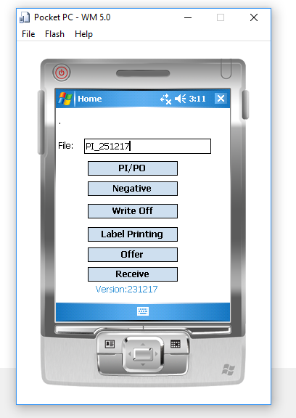

Step1: For PI count, type file name and click on PI button.

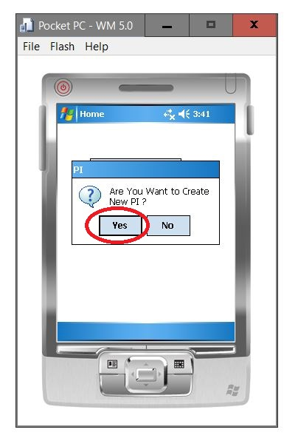

Step2: Enter location details and scan the barcode.

Step3: Save all scanned barcodes.

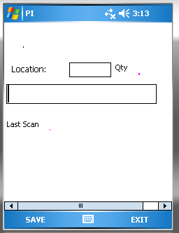

1. **Write Off**

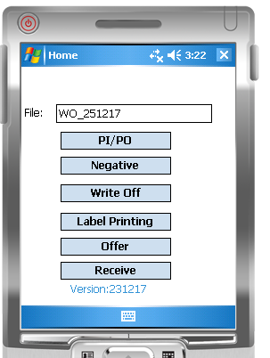

Step1: For Write-off count ,type file name and click on Write Off button.

Step2: Enter location details and scan the barcode.

Step3: Save all scanned barcodes.

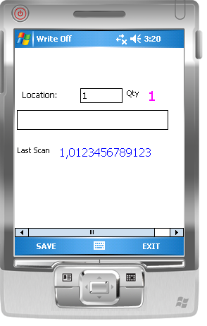

1. **Negative**

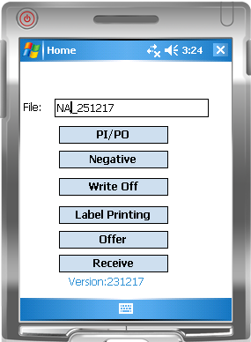

Step1: You need to save the barcode file which exported from desk top app in //My Documents folder (NA_Data.csv)

Step2: Type file name and click on “Negative” button.

Step3: Enter location details and scan the barcode.

Step4: Save all scanned barcodes.

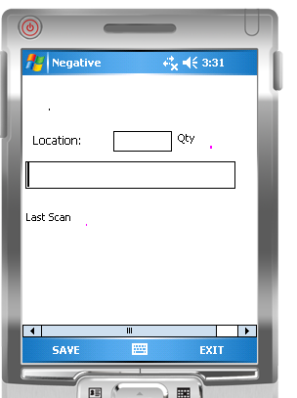

1. **Label Printing**

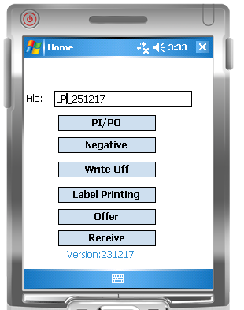

Step1: Type file name and click on “Label Printing” button.

Step2: Enter Quantity and scan the barcode.

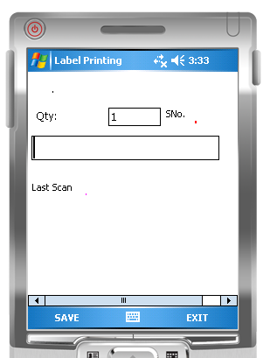

Step3: Save all scanned barcodes.

1. **Offer**

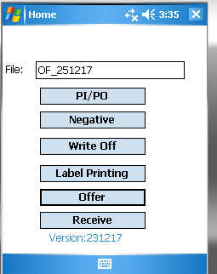

Step1: You need to save the Offer file which received from HO in //My Documents/Offer folder (Offer.csv)

Offer format file is as below

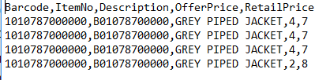

Step2: Type file name and click on “OFFER” button.

Step3: Enter Qty and scan the barcode then you can see offer details.

Step4: Save all scanned barcodes.

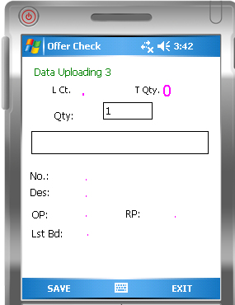

# Desktop Application

1. **Login**

In this form you can enter your username and password, and then login to the application.

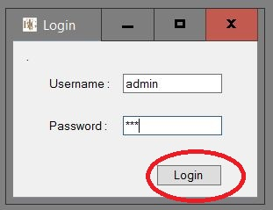

1. **Change Password**

This option is for changing your password. In this form you have enter your current password and new password, and the click on Change password button

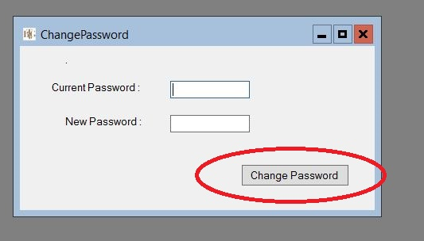

1. **Update Item Master**

This option is for update item master table in the system. In this form you need to click Refresh button form update item master. This process will take 5- 10 Minutes. You must update item master before every PI and it is a one time job for one PI schedule.

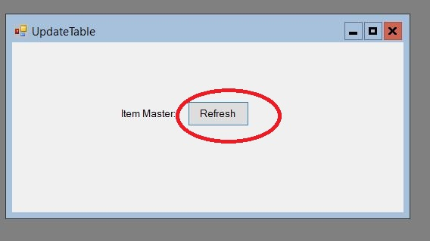

1. **New PI Work Sheet**

This option is for creating new PI work sheet.

* 1. **Import Data File**

After PDT scanning you will get data files(PI_Data.csv).You need to import that into the system.

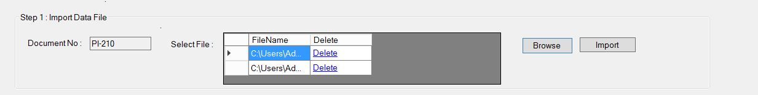

* 1. **Select Filters**

This option is for selecting filters depending upon the PI Schedule.

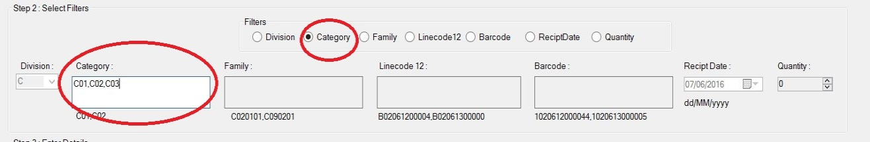

* 1. **Enter Details and Reporting**

In this option, you can enter scanning details and click on Report button then variance report will generate as per the scanning.



* 1. **Export Report**

This option is for generating report(.csv files).

Export All-> will generate all lines.

Export Variance-> will generate variance only.

In the variance report you can edit “manual count” in case of variance.

Send the file to HO.

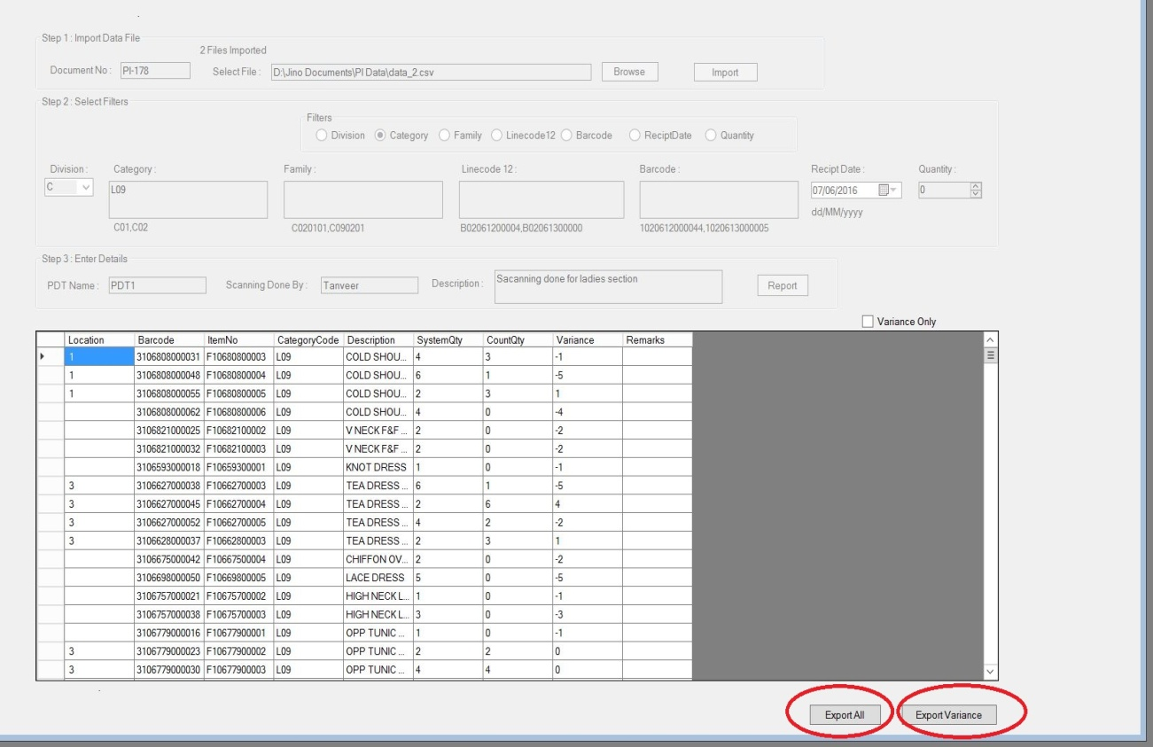

1. **Write Off**

This option is for creating new Write-off work sheet.

* 1. **Import Data File**

After PDT scanning you will get data files(WO_Data.csv).You need to import that into the system.

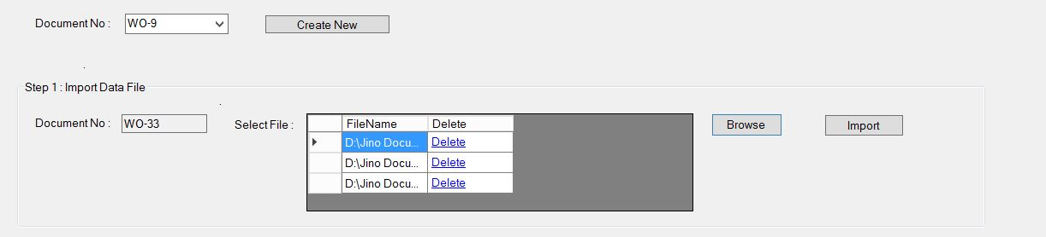

* 1. **Enter Details and Reporting**

In this option, you can enter scanning details and click on Report button then variance report will generate as per the scanning.

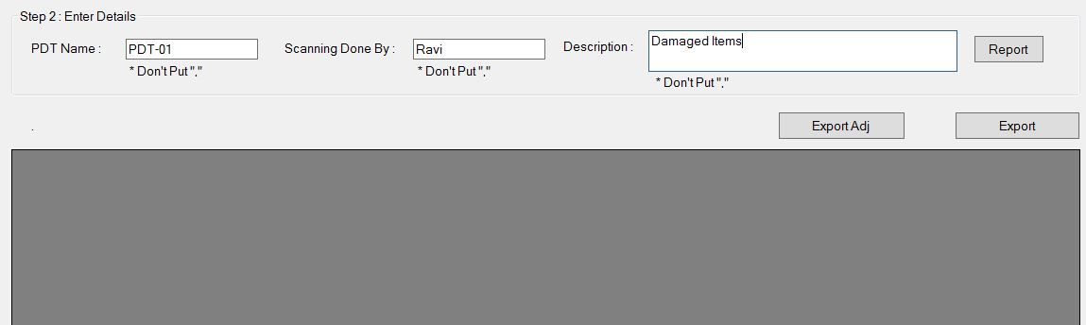

* 1. **Export Report**

This option is for generating report(.csv files).

Export -> will generate all lines.

Export Adj-> will generate adjustment format.

In the adjustment report you can edit Manual Count and send to HO .

1. **Negative Count**

This option is for creating new Negative work sheet.

* 1. **Export Negative Barcodes**

First you need to export negative barcodes existing in the system and save that file inside PDT “My documents” folder.

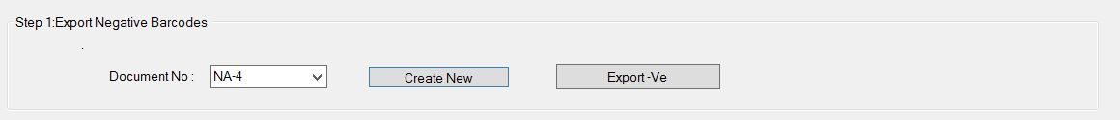

* 1. **Import Data File**

After PDT scanning you will get data files(Neg_Data.csv).You need to import that into the system.

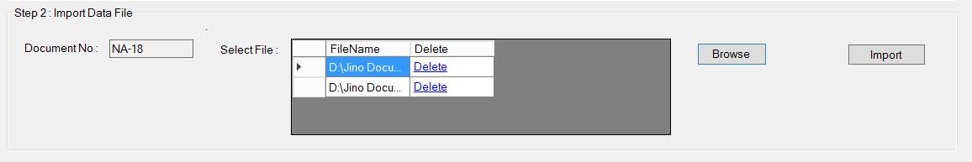

* 1. **Enter Details and Reporting**

In this option, you can enter scanning details and click on Report button then variance report will generate as per the scanning.



* 1. **Export Report**

This option is for generating report(.csv files).

Export -> will generate all lines.

Export Adj-> will generate adjustment format.

In the adjustment report you can edit Manual Count and send to HO 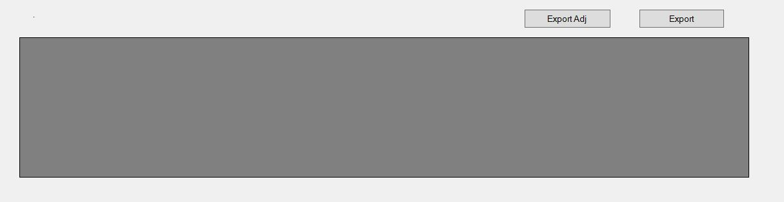

1. **Purchase Order**
   1. **Import PO file**

Import the PO file which is send from head office

Format

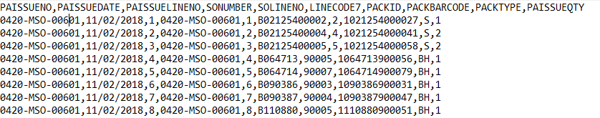

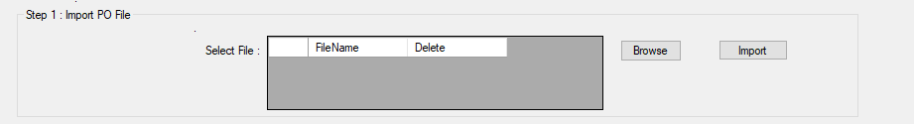

* 1. **Import Data File**

Import the data file from PDT

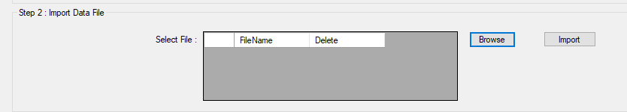

* 1. **Enter Details**

Please enter details of scanning and click on “Report”

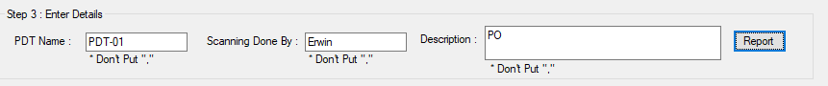

* 1. **Export Report**

Export the report and send to head office

If you click on print PO button, you can print the labels from Nav.

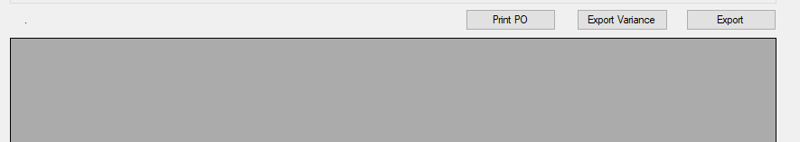

1. **Label Printing**

This option is for printing labels

* 1. **Import Data File**

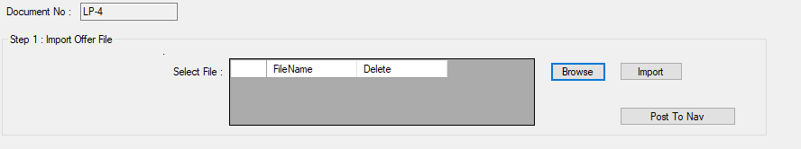

Import the data file from PDT and click on “Post to Nav” Button, then you can print labels from Nav.

1. **Reports**

This option is for generating various reports. In this form you need to select Report type and document No. then click on export button.

